PIZZA SALES SQL QUERIES

A.KPI’S
1-.Total Revenue
SELECT SUM(total_price) AS Total_Revenue from pizza_sales;
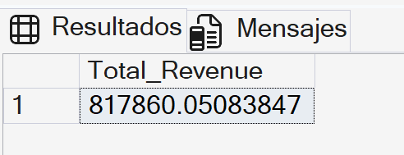
2-.Average Order Value
SELECT SUM(total_price) / COUNT(DISTINCT order_id) AS Avg_Order_Value FROM pizza_sales
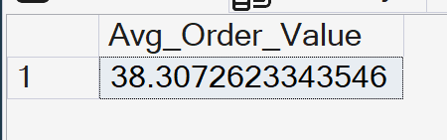
3-.Total Pizzas Sold
SELECT SUM(quantity) AS Total_Pizzas_Sold from pizza_sales
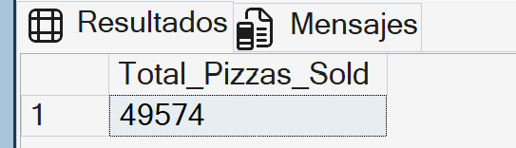
4-.Total Orders
SELECT COUNT(DISTINCT order_id) AS Total_Orders FROM pizza_sales
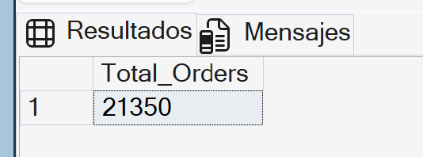
5-.Average Pizzas Per Order
SELECT CAST(CAST(SUM(quantity) AS DECIMAL(10,2)) /
CAST(COUNT(DISTINCT order_id) AS DECIMAL(10,2)) AS DECIMAL(10,2)) AS Avg_Pizzas_Per_Order from pizza_sales
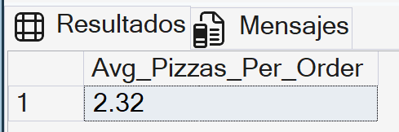

B.Charts
1-. Daily Trends
SELECT DATENAME(DW, order_date) AS Order_Day, COUNT(DISTINCT order_id) AS Total_Orders
FROM pizza_sales
GROUP BY DATENAME(DW, order_date)
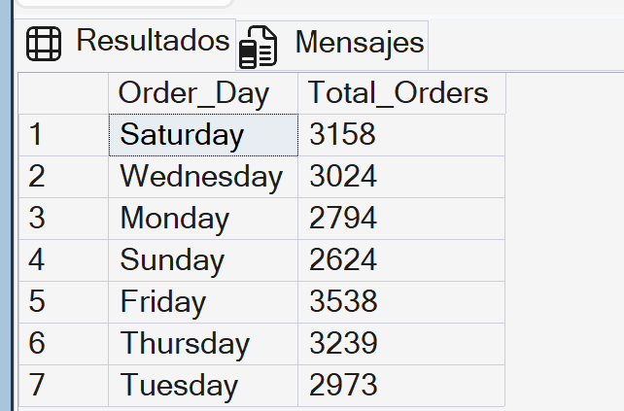

2-.Hourly Trend
SELECT DATEPART(HOUR, order_time) AS Order_Hours, COUNT(DISTINCT order_id) AS Total_Orders
FROM pizza_sales
GROUP BY DATEPART(HOUR, order_time)
ORDER BY DATEPART(HOUR, order_time)
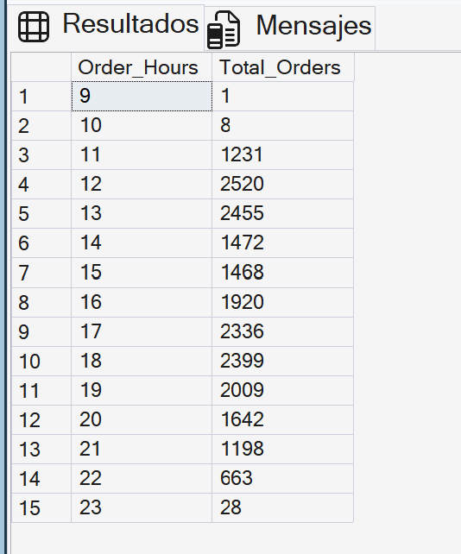

3-.Percentage of Sales by Pizza Category
SELECT pizza_category, SUM(total_price) as Total_Sales, sum(total_price) * 100 / (SELECT sum(total_price) FROM pizza_sales) AS PCT
FROM pizza_sales
GROUP BY pizza_category
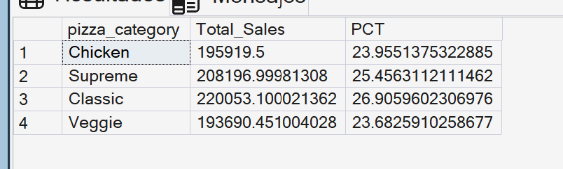
NOTE: If you want to filter for month you can add “WHERE MONTH(order_date) = _”. For example if you write WHERE MONTH(order_date) = 1, it will show January, but also keep in mind that you have to write the subquery like (SELECT sum(total_price) FROM pizza_sales WHERE MONTH(order_date) = 1)

4-.Percentage of Sales by Pizza Size

SELECT pizza_size, CAST(SUM(total_price) AS DECIMAL(10,2)) as Total_Sales, CAST(sum(total_price) * 100 / (SELECT sum(total_price) FROM pizza_sales) AS DECIMAL(10,2)) AS PCT
FROM pizza_sales
GROUP BY pizza_size
ORDER BY PCT DESC
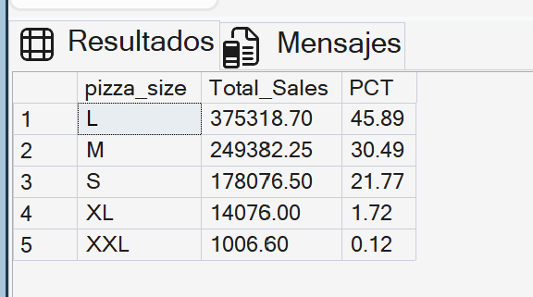
NOTE: If you want to filter for month you can add “WHERE MONTH(order_date) = _”. For example if you write WHERE DATEPART(quarter, order_date) = 1, it will show January, but also keep in mind that you have to write the subquery like (SELECT sum(total_price) FROM pizza_sales WHERE DATEPART(quarter, order_date) = 1)

5-.Total Pizzas Sold by Pizza Category
SELECT pizza_category, sum(quantity) as Total_Pizzas_Sold
FROM pizza_sales
GROUP BY pizza_category
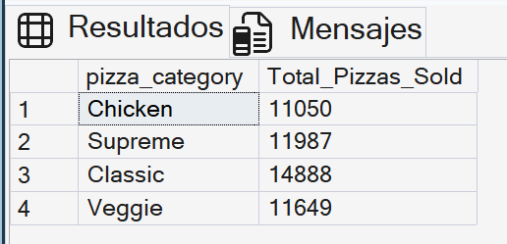

6-.Top 5 Best Sellers by Total Pizzas Sold
SELECT TOP 5 pizza_name, sum(quantity) as Total_Pizzas_Sold
FROM pizza_sales
GROUP BY pizza_name
ORDER BY sum(quantity) DESC
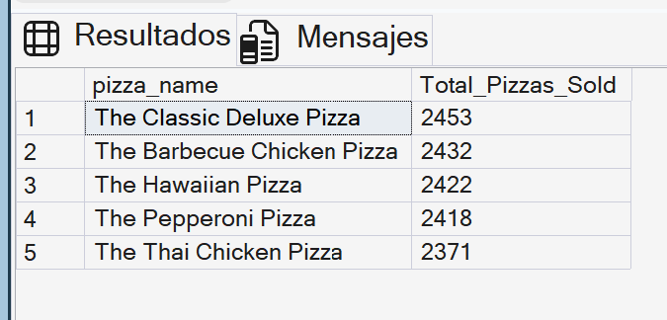

7-.Bottom 5 Best Sellers by Total Pizzas Sold
SELECT TOP 5 pizza_name, sum(quantity) as Total_Pizzas_Sold
FROM pizza_sales
GROUP BY pizza_name
ORDER BY sum(quantity) ASC
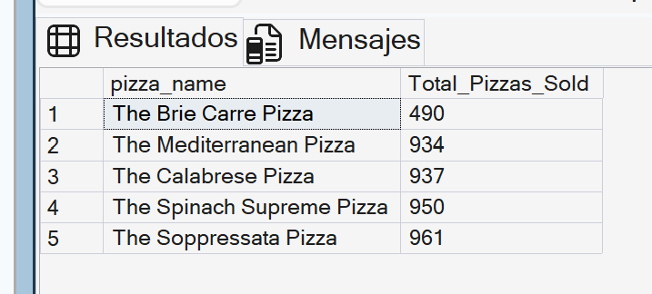
Note: You can filter like:
SELECT TOP 5 pizza_name, sum(quantity) as Total_Pizzas_Sold
FROM pizza_sales
WHERE MONTH(order_date)=1
GROUP BY pizza_name
ORDER BY sum(quantity) ASC
